The Circuit Extra Credit
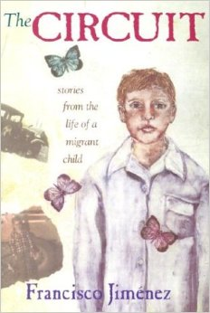
Directions: Complete one or more of the following extra credit assignments to receive a bonus quiz grade.
1. Read another book by the author Francisco Jimenez. His titles include:
Reaching Out, Breaking Through, The Christmas Gift, and La Mariposa. Complete a reading journal entry on the book.

2. Research books and the Internet to learn about the author, Dr. Francisco
Jimenez. Use the information to create a Powerpoint presentation.

3. Create a sculpture of one of the characters in the book. Use materials such as clay, sticks, wire, cloth, etc. Share your sculpture with the class, explaining how he or she was important to the story.

4. Write an eight-line poem about one of the characters. Make an illustrated poster of your poem and share it with the class.

5. Write an essay explaining the meaning of the book's title, The Circuit. Include the actual meaning of the word "circuit" and how it relates to the story.

6. Create a diorama for one of the chapters from the book. Determine the chapter's main event to depict. Write a short summary of the chapter on an index card and attach it to the diorama.

7. Use a map of Mexico and California to trace the journey of the Jiménez family as they journeyed from Guadalajara, Mexico to many towns in California. Identify and label each important stop the family made.

